
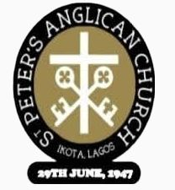
THE DIOCESE OF LAGOS
ST PETER’S ANGLICAN CHURCH, IKOTA
(SPACIK)
Ikota Road 1, by Ikota Primary School, off Ikota School Bus-Stop, Lagos
P. O. Box 73962, Victoria Island, Lagos.
(PENINSULA ARCHDEACONRY)

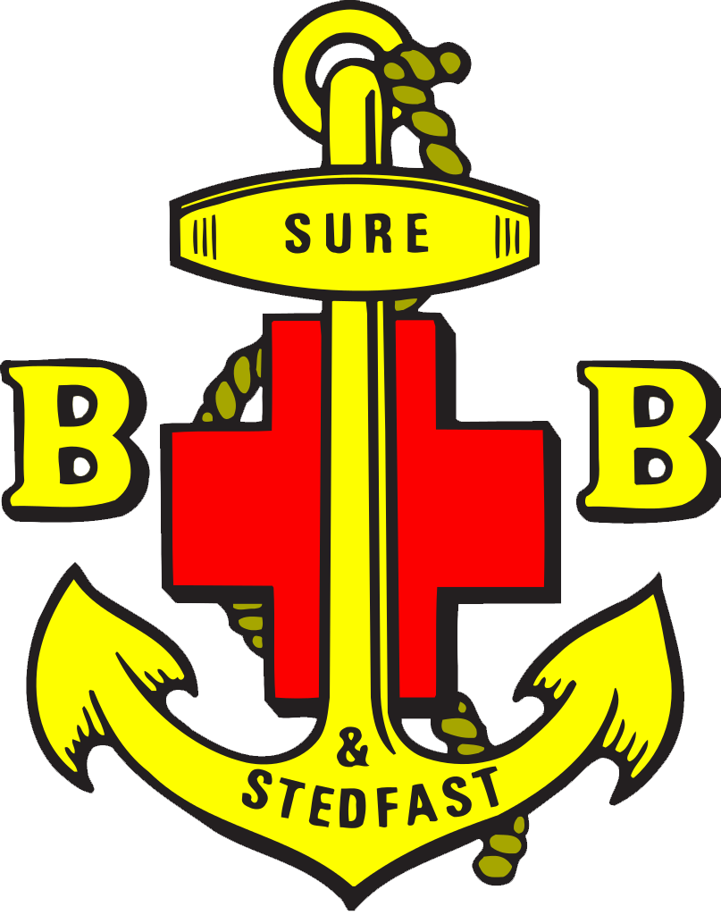

\

THE BOYS’ BRIGADE NIGERIA
LAGOS STATE COUNCIL
LAGOS SOUTH BATTALION COUNCIL

INAUGURATION & 1ST ENROLMENT SERVICE OF THE
34TH COMPANY OF LAGOS SOUTH BATTALION

DATE: SUNDAY 10th AUGUST, 2025
TIME: 10:00am
VENUE: ST PETER’S ANGLICAN CHURCH, IKOTA
Ikota Road 1, by Ikota Primary School, off Ikota School Bus-Stop, Lagos


Sir William Alexandar Smith KBE
Founder, The Boys’ Brigade
27th October 1854 - 14th May, 1914

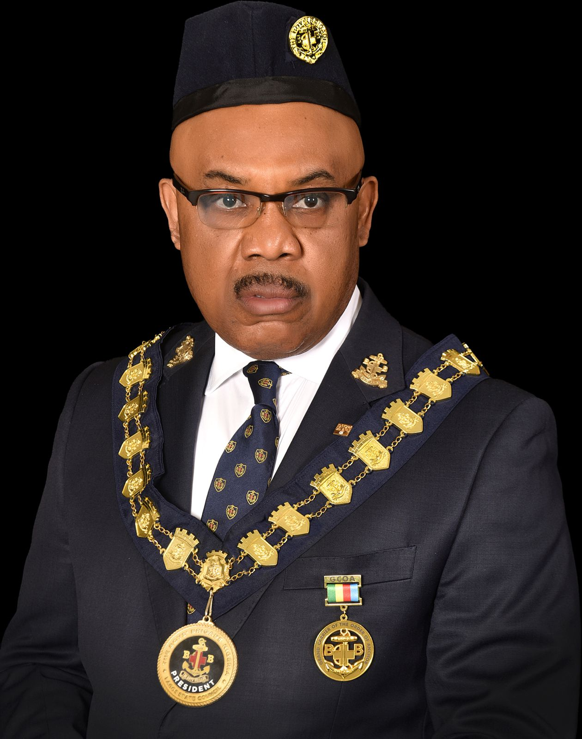
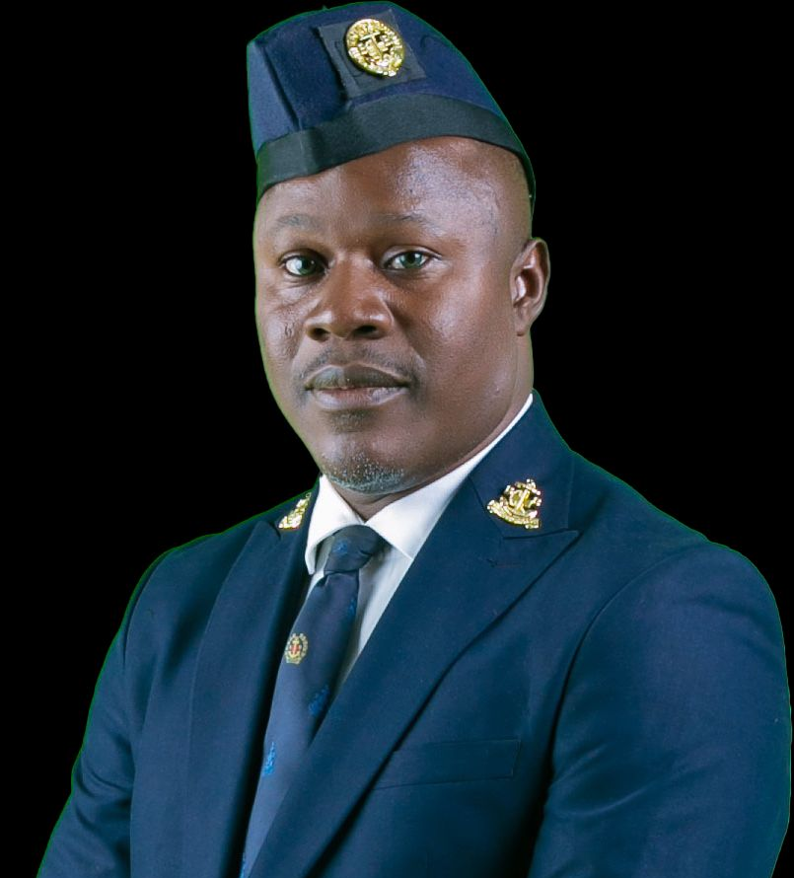

Elder U. K. Eke, FCIoD, FCA, MFR, GCOA Sir Charles-Jeffrey Diete-Koki ANTO, CCOA
President, Lagos State Council State (Executive) Secretary/Organizer
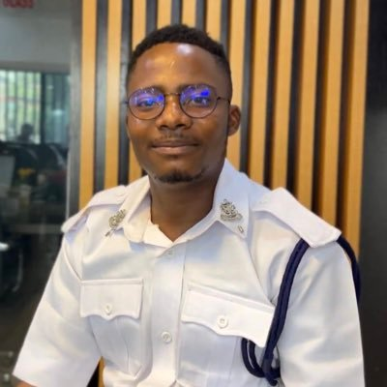
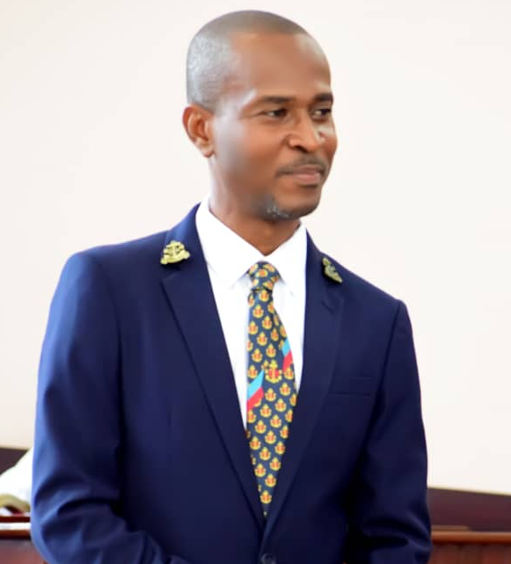
Mr Oladimeji Bamigbele ANTO Mr Taiwo Obasan STO
Chairman, Lagos South Battalion Council Battalion Secretary/Administrator

Ven Dr Stephen A. Adeyemi
Chaplain, 34th Lagos South Company

MR. Okuneye Adeyinka Ghold
Captain, 34th Lagos South Company

ORDER OF SERVICE

- PROCESSIONAL HYMN
- MARCHING IN THE BATTALION COLOURS
- PRAISE & WORSHIP
- CALL TO WORSHIP
- BENEDICTUS – WB (Page 19-20)
- THE BIBLE READING
- CREED TO COLLECT
- HYMN
- SERMON
- HYMN: (SEED OF FAITH)
- INTERCESSION
- COVENANT OFFERINGS: TITHE, NEHEMIAH-VOW, FREEWILL & SUNDAY COLLECTION
- BRIGADE CEREMONIES
- INAUGURATION of 34Th LAGOS SOUTH COMPANY & PRESENTATION OF THE BOYS’ BRIGADE CERTIFICATE
- DEDICATION OF NEW COLOURS
- INSTALLATION OF CHAPLAIN
- INSTALLATION OF CAPTAIN
- ENROLMENT OF OFFICERS
- ENROLMENT OF BOYS
- INDUCTION OF PATRONS AND PATRONESSES
- DECLARATION BY CONGREGATION
- GIRLS BRIGADE ACTIVITIES
- NOTICES
- THANKSGIVING
- I have a reason to praise God
- Peninsula Archdeaconry Pastorate Anniversary Support
- Any Other
- BENEDICTION
- COLOUR PARTY RECESSION
- RECESSIONAL HYMN

T H E B O Y S’ B R I G A D E N I G E R I A
L A G O S S T A T E C O U N C I L

B R I G A D E C E R E M O N I E S

- The Boys’ Brigade Ceremonies “Will your anchor hold”

  - Will your anchor hold in the storms of life,
When the clouds unfold their wings of strife?
When the strong tides lift and the cables strain,
Will your anchor drift or firm re-main?
Refrain:
We have an anchor that keeps the soul
Steadfast and sure while the bil-lows roll,
Fastened to the rock which can-not move,
Grounded firm and deep in the Saviour's love!
  - Will your anchor hold in the straits of fear,
When the breakers roar and the reef is near?
While the surges rave and the wild winds blow,
Shall the angry waves then your bark o'er flow?
(Refrain)

  - Will your anchor surely hold in the floods of death,
When the waters cold chill our latest breath;
On the rising tide it can never fail,
While our anchor holds within the veil.

(Refrain)
4. Will your eyes behold through the morning light
The city of gold and the harbour bright?
Will you anchor safe by the heavenly shore,
When life's storms are past forever- more?

INAUGURATION OF
34Th COMPANY OF LAGOS SOUTH BATTALION

BATTALION SECRETARY: Whereas St. Peter’s Anglican Church, Ikota applied to The Boys’ Brigade Nigeria for the registration of a Boys’ Brigade Company:

Having fulfilled the requirements of the procedure for the registration of the Company, The Boys’ Brigade Nigeria approved and registered the Company as the 34th Lagos South Company attached to St. Peter’s Anglican Church, Ikota.

I, ‘Obasan Taiwo, Secretary Lagos South Battalion Council hereby invite the State Secretary/Organiser for the inauguration of the Company.

STATE SECRETARY: On behalf of The Boys’ Brigade Nigeria, I, DIETE-KOKI CHARLES-JEFFREY hereby inaugurate the 34th Lagos South Company of The Boys’ Brigade, Nigeria attached to St. Peter’s Anglican Church, Ikota in the name of God the Father, the Son and of the Holy Spirit, Amen.

SECRETARY/ORG: “Members of the State Executive Council here present, Chairman and Executive members of the Lagos South Battalion Council, by the virtue of power vested in the Lagos State Council of the Boys’ Brigade by the National body I present this certificate of registration to the St. Peter’s Anglican Church, Ikota, today – 10th August 2025 – in the name of God the Father, God the Son and God the Holy Spirit.”

ALL: AMEN.

DEDICATION AND PRESENTATION OF COMPANY COLOURS

(The Flag is brought in by a Boy in slow March and presented to the Battalion Chaplain)
BATTALION CHAPLAIN: “Forasmuch as men at all times have made for themselves signs and emblems of their allegiance to their rulers, and of their duty to uphold those laws and institutions which God’s providence has called them to obey; we, following this natural and pious custom and remembering that God Himself led His people Israel by a pillar of fire by night and a pillar of cloud by day, are met together before God to ask His blessing on these new Colours which are to represent to us our duty towards our Sovereign and our Country. Let us, therefore, pray Almighty God of His mercy to grant that they may never be unfurled save in the cause of justice and righteousness: and that He may make them to be to those who follow them a sign of His presence with them, and may increase their faith and hope in Him Who is the King of Kings and Lord of Lords.”
(The Battalion Chaplain will then lay his hands upon the Colours and say: - )
“In the Name of the Father, and of the Son, and of the Holy Ghost, we do dedicate and set apart these Colours, that they may be a sign of our duty towards our Church, our Country, and The Boys’ Brigade in the sight of God. Amen.”
“O God, the help and shield of all who trust in Thee, accept our service at this time and grant that the 34th Lagos South Company of The Boys’ Brigade Nigeria Colours now dedicated may never be unfurled except for the glory and the advancement of Christ’s Kingdom. May Thy blessing descend upon those to whom has been committed this new token of Thy love and this new trust in their work. May Officers, Boys and Girls be ever conscious of their high calling and obedient to the heavenly vision. May they fight only the good fight of faith that they may lay hold upon eternal life. May they be faithful unto death and receive a crown of life through Him Who died for us and rose again; unto Whom with Thee, the Father, and the Holy Ghost be Glory and majesty, dominion and power, both now and ever. Amen.”
All: AMEN.

B. INVESTITURE OF COMPANY CHAPLAIN
(The Chaplain is brought in by the Battalion Secretary in slow march with a guard formed by Officers and the Congregation standing)
BATTALION SEC.: I present our Father in the Lord, Ven. Dr. Stephen A. Adeyemi to be invested as the Chaplain of the 34th Lagos South Company of the Boys’ Brigade Nigeria attached to the St. Peter’s Anglican Church, Ikota.
STATE SEC./ORG: Our dear Father in the Lord, by virtue of your office as a Minister-in-Charge of the Church, you have been appointed as the Chaplain of the 34th Lagos South Company. It is then our business at this solemn Service to invest you formally into the office of the Chaplain of the 34th Lagos South Company. This we shall do, when publicly you re-affirm your total support for The Boys’ Brigade Nigeria.
CHAPLAIN: Realizing my responsibilities as the Chaplain of the 34th Lagos South Company, I, Ven. Dr. Stephen A. Adeyemi declare that I will do my best in every possible way in furthering the Object of The Boys’ Brigade. I will give respect to the constituted authorities among the rank and file of The Brigade. I will co-operate with the executives and members of the Brigades at the Global Fellowship, Regional Fellowship, National, State, Battalion & District levels. I also promise to use my office as spiritual leader with the fear of God in my heart to be truthful in all things and try my possible best at all times to seek the good of The Boys’ Brigade. I will also see to the payment of Annual Renewal Fees and other necessary dues to the appropriate quarters. Furthermore, I shall occasionally visit the Boys and Officers during their meetings in order to advice and encourage them in the task of advancing Christ’s Kingdom and character training of The Boys. All these I promise, in the name of the Father, Son and Holy Spirit. Amen.
(The Battalion Chaplain blesses the instruments of Office and the Chaplain is decorated by State officials)
BAT. CHAPLAIN: Let us pray… (Company Chaplain kneels) Oh Lord, our heavenly Father, we beseech Thee to mercifully look upon Thy chosen servant Ven. Dr. Stephen A. Adeyemi whom we have invested and decorated as Chaplain of the 34th Lagos South Company of The Boys’ Brigade Nigeria attached to The St. Peter’s Anglican Church, Ikota. Fill him with your love so that his tenure may be progressive, just and with righteousness and at the end may he win your eternal and incorruptible crown, through the might and power of our Lord and Saviour Jesus Christ.
ALL: Amen.
STATE SEC./ORG: By the authority conferred on me by the Boys’ Brigade Nigeria, I formally confirm your appointment as the CHAPLAIN of the 34th Lagos South Company of the Boys’ Brigade Nigeria to the glory of God and for the progress of the Church, the growth of the Brigades and for the spiritual wellbeing of our Boys. May Jesus Christ the commander of His soldiers grant you the strength and divine grace to discharge your responsibilities faithfully and crown your efforts with success.
(Facing the Congregation and raising the right hand of the Chaplain) 34th Lagos South Company: BEHOLD YOUR CHAPLAIN.
((((((((((((((((((FANFARE))))))))))))))))))))))))))

C. ENROLMENT CEREMONIES

i. INSTALLATION OF THE CAPTAIN
(The Captain shall be brought to the front of the Chancel by the Battalion Secretary while a guard of honour shall be mounted by Captains present)
BAT. SECRETARY: “Sir, I present to you our brother in the Lord, Ghold Olayinka Okuneye to be installed as the Captain of the 34th Lagos South Company of The Boys’ Brigade Nigeria attached to The St. Peter’s Anglican Church Ikota.”
CHAPLAIN: Brother Okuneye Adeyinka Ghold realising the priviledge of presenting the claims of our Lord Jesus Christ to Boys and Young men in the first formative years of their lives and the responsibilities involved in the leadership of the 34th Lagos South Company and recognising your dependence upon God’s strength, would you now give your undertaking to serve God by furthering the object of The Boys’ Brigade?
CAPTAIN: I Okuneye Adeyinka Ghold hereby promise to serve God by furthering the Object of The Boys’ Brigade, which is the Advancement of Christ’s kingdom among Boys and the promotion of habits of Obedience, Reverence, Discipline, Self-Respect and all tends towards a true Christian manliness.
CHAPLAIN: Having desired to be inducted, will you declare before God and this congregation of God’s people that you are not a member and will not take up membership of any secret society or cult so as long as you are a member of the Boys’ Brigade Nigeria.
CAPTAIN: I, Okuneye Adeyinka Ghold affirm and solemnly declare before God and this congregation that I do not belong to any secret society or cult and will not take up membership of any all the days of my life and that I will not be involved directly or indirectly in their activities. I know and believe that if I am not sincere and honest in this declaration, I place myself under the wrath of God in the name of the Father, Son and Holy Spirit. Amen.
CHAPLAIN: See that you keep what has been committed into your charge. May God give you grace to be faithful to him and successful in your work for Him in The Boys' Brigade.
CAPTAIN: Amen.
CHAPLAIN: I install you as the Captain of the 34th Lagos South Company of the Boys’ Brigade Nigeria in the name of God the Father, Son and Holy Spirit.
ALL: AMEN
CHAPLAIN: Bro Okuneye Adeyinka Ghold take your staff of office. Use it to tend your sheep carefully but diligently like Jesus Christ the good Shepherd. Take your appointment card, an evidence of your membership of this corporate body advancing Christ’s kingdom. May God grant you grace to be faithful to your trust. AMEN.
SEC./ORG: (Decoration of The Captain) Bro. Okuneye Adeyinka Ghold having been appointed by the Church Authority according to your bidding and dully installed as the Captain, you will henceforth continue to enjoy full privileges like other Captains. You can now take your seat among Captains at all forums of The Boys’ Brigade in accordance with the constitution of the Boys’ Brigade Nigeria. You are the authorised link between the Church and the Councils.
(To the Congregation) The task of manning human beings is the most difficult. We therefore solicit your full support for him in nurturing the young ones committed to his charge. Remember him always in your prayers. May the Lord rule, direct and uphold him for Christ’s sake. AMEN.
St. Peter’s Anglican Church, Ikota, BEHOLD YOUR CAPTAIN.

ENROLMENT OF OFFICERS
(The Captain calls the officers to be inducted to the front of the Chancel)
CAPTAIN: “Sir, I present to you these men who have agreed to be enrolled as Officers of The 34th Lagos South Company of the Boys’ Brigade Nigeria.”
CHAPLAIN: You have been called by God to the work of caring for and training the Boys of our Company. Will you by your work and example seek to advance Christ’s Kingdom and work in partnership with the Church to share the gospel of Jesus Christ?
OFFICERS: With God’s help, I will.
CHAPLAIN: Will you by prayer and personal preparation seek to equip yourself in every possible way for this service?
OFFICERS: With God’s help, I will.
CHAPLAIN: Having read and understood the constitution of The Boys’ Brigade Nigeria, do you promise at all times to uphold the object of the organisation and live by its rules and regulations?
OFFICERS: With God’s help, I will.
CHAPLAIN: Do you therefore wish to be inducted as Officers of the 34th Lagos South Company of the Boys’ Brigade Nigeria?
OFFICERS: This is my desire.
CHAPLAIN: Having desired to be so inducted, will you declare before God and this congregation of God’s people that you are not a member and will not take up membership of any secret society or cult so as long as you are a member of the Boys’ Brigade Nigeria.
OFFICERS: I ____________________________________________________affirm and solemnly declare before God and this congregation that I do not belong to any secret society or cult and will not take up membership of any all the days of my life and that I will not be involved directly or indirectly in their activities. I know and believe that if I am not sincere and honest in this declaration I place myself under the wrath of God in the name of the Father, Son and Holy Spirit. Amen.
CHAPLAIN: See that you keep what has been committed into your charge. May God give you grace to be faithful to him and successful in your work for him in The Boys' Brigade.
OFFICERS: Amen.
CHAPLAIN: I induct you as Officers of the 34th Lagos South Company of the Boys’ Brigade Nigeria in the name of God the Father, Son and Holy Spirit.
OFFICERS: Amen.
CHAPLAIN: Let us pray…. (Blessings)
(Decoration of Officers by The Battalion Officers and presentation of appointment cards by the Chaplain.)

ENROLMENT OF BOYS
(The Captain calls the Boys to be inducted)
CAPTAIN: “Sir, I present to you these Boys who desire to be enrolled as members of the 34th Ikeja Company of the Boys’ Brigade Nigeria – attached to The St. Peter’s Anglican Church, Ikota.
CHAPLAIN: Boys who desire to be enrolled as members of the 34th Lagos South Company of the Boys’ Brigade Nigeria connected to The St. Peter’s Anglican Church, Ikota would you promise to obey the rules of the Company and set an example of good conduct to your comrades and other Boys and also to be faithful in your attendance??
BOYS: Yes I do the Lord being my helper.
CHAPLAIN: I welcome and receive you into the fold of the 34th Lagos South Company of the Boys’ Brigade Nigeria. May God the Captain of your salvation give you strength to be faithful to your duty, loyal to your comrades, strong in times of temptation and to be His faithful servant always.
BOYS: Amen.
CHAPLAIN: Let us pray… (Blessings) (Chaplain shakes hand with them and give them membership cards)
INDUCTION OF PATRONS & PATRONESSSES
(The Captain calls the inductees to the front of the chancel)
CAPTAIN: “Sir, I present to you these men and women of repute and integrity who have agreed to be enrolled as Patrons of the 34th Lagos South Company of the Boys’ Brigade Nigeria.”
CHAPLAIN: Having been honoured with this office, do you promise to assist the Brigades financially, morally and prayerfully in order to encourage the officers in their task of advancing Christ’s kingdom and help in the character development of the Boys?
PATRONS: I promise to work for the fulfilment of the Boys’ Brigade Nigeria and 34th Lagos South Company respectively at all times, to give my prayer, moral and financial support, and also to do all that I can to encourage the officers in their task of advancing Christ’s kingdom. So help me God.
CHAPLAIN: See that you keep what has been committed into your charge.
OFFICERS: Amen. God being my helper.
CHAPLAIN: I induct you as Patrons and Patronesses of the 34th Lagos South Company of the Boys’ Brigade Nigeria in the name of God the Father, the Son and the Holy Spirit.
OFFICERS: Amen.
CHAPLAIN: Let us pray…. (Blessings)
(Decoration of Officers by State & Battalion Officers… The Chaplain shakes hands with them as they retire to their seats.)

v. DECLARATION BY THE CONGREGATION:

CHAPLAIN: Finally, I have a question to the congregation. Do you promise to support the work of our Company of The Boys’ Brigade and to pray for the Captain, Officers and Boys that God will keep them sure and steadfast in their faith and to help them become strong followers of the Lord Jesus Christ and through reverence, self-control and a sense of responsibility that they may find true enrichment of life and grow to full Christian manliness?

CONGREGATION: Yes, we do, God being our helper

CHAPLAIN: Let us then say the Boys, Brigade prayer together.

ALL: Bless, O God, The Boys’ Brigade and give to it greater power to advance Your Kingdom throughout the world. Grant your mercy that every member past and present, may prove steadfast in his fight against evil and true in his allegiance to You. Help us in times of temptation, make us strong where we are weak, give us courage in difficulty, faithfulness in duty, loyalty in friendship and finally by Your mercy, bring us into Your everlasting Kingdom through Jesus Christ, our Lord. Amen.

- Cap Collection In Aid Of the New Company
- Short Speech By The Battalion Chairman: Mr. ‘Ladi Bamgbele
iv. BOYS’ BRIGADE ANTHEM

- Underneath the Banner
Of the Cross Arrayed,
Lord we ask thy Blessing,
On The Boys’ Brigade
Thou art our Commander,
And Thy soldiers we
And in Christian warfare
We would honour Thee.

Refrain:
Underneath the Banner
Of the Cross Arrayed
Lord we ask Thy Blessing
On The Boys’ Brigade.

- In each lowly service
As on Drill Parade,
“Duty” be the watchword
Of The Boys’ Brigade;
Make us ever loyal
Small or great the foe;
Lead us, Saviour! lead us,
Everywhere we go

- We will fight for laurels
That will never fade;
For the Holy City
March The Boys’ Brigade;
What we find unholy
In our daily life,
We will try to conquer –
Help us in the strife

LIST OF HONOURARIES/OFFICEBEARERS
- STATE HONOURARIES/OFFICE BEARERS
- Elder U. K. Eke MFR GCOA - President
- Very Rev. H. S. A. Osindehinde - Vice President (Training & Extension)
- Snr. Sp. Apostle Surv. ‘Deji Sebiotimo - Vice President (Administrative & Projects)
- Mr. Olugbolaga Ajayi Esq - Vice President (Finance & Investments)
- Captain ‘Dotun Henry Ogunyemi - Vice President (National & International Relations)
- Mr. Charles-Jeffrey Diete-Koki ANTO - State Secretary/Organizer
- Mr. Olufemi George - Treasurer
- Hon. Adedipo Solomon Otegbayo - PRO
- Mr. William Anu Adefeso - Auditor

- LAGOS SOUTH BATTALION EXECUTIVES
- Ladi Bamigbele ANTO (Capt.) – Chairman
- Samuel Daniel Bala (Capt.) - Vice Chairman
- Taiwo Obasan STO (Capt.) - Secretary / Administrator
- David Jireh (Capt.) - Assistant Secretary
- Moses Ukelina STO (Capt.) - Training Convener
- Musa Mutah (Capt.) – Treasurer
- Mackristopher Ejikeme (Capt.) - Financial Secretary
- Simon Ephraim Alari (Lt.) - Public Relations Officer
- Iliya Seth (Lt.) - Internal Auditor
- Ajah Daniel (Lt.) - Welfare/Visiting Officer Sangotedo – Okegun Zone
- Ikenna Onwuka (Capt.) - Welfare/Visiting Officer Lekki I – Abraham Adesanya Zone
- Yohanna Jennifer - Welfare/Visiting Officer Obalende/Ikoyi – Victoria Island Zone
- Folorunsho Odusanya - Music Director / Band Master
- The Rev’d Gabriel Umoibe - Battalion Chaplain

- LAGOS SOUTH BATTALION GRAND PATRON, PATRON and PATRONESSES
- Elder Joshua Giwa
- Sir ‘Demola Ben Aladekomo KJW, HOA
- Sir Kolapo Solesi KJW, HOA
- Sir Victor Anorue
- Dame Anike Adegbola
- Mrs Yetunde Adeyemo
- Mrs Cordelia Ikeanyi-Dike

- The Boys’ Brigade Nigeria, 34th Lagos South Company
- Ven. Dr. Stephen A. Adeyemi - Chaplain
- Mr Olayinka Ghold Okuneye - Captain
Warrant Officers

Anchor Boys (3 – 7 yrs)

Junior Section ( 8 – 11 years)

Company Section (12 – 15 years)

Senior Section (16 – 18 years)

Patrons & Patronesses
- Mr Joseph Majiyegbe
- Mr Kayode Akinyanbola
- Mr Walter Babantah
- Mrs Bukola Jeje
- Mrs Oloworanran
- Mrs Naomi Omomehin
- Mrs Olufunke Okueyungbo
- Mrs Suzie Wobo
- Mrs Tayo Taiwo

PART II

DECLARATION AND DEDICATION OF OFFICERS AND GIRLS

(The Girls March forward according to their ranks in quick March).

COMMANDANT: Sir I present to you these girls and officer of ST. PETER’S CHURCH, IKOTA LEKKI, LAGOS for Declaration and Dedication.

CHAPLAIN: Officers and Girls of ST. PETER’S CHURCH, IKOTA LEKKI, LAGOS recites the Aim of the Girls Brigade.

OFFICERS/GIRLS: The aim of the Girls Brigade is to help girls become the follower of our Lord Jesus Christ, through self-control, reverence and sense of responsibilities to find true enrichment of life.

CHAPLAIN: Officers and Girls of ST. PETER’S CHURCH, IKOTA LEKKI, LAGOS Realizing your responsibilities as officers and girls, Do you promise to serve God so that you will be able to fulfill the aim of the girls’ brigade and continue to do your utmost to keep the girls brigade laws in letters and spirit?

OFFICERS/GIRLS: I do promise God being my helper.
CHAPLAIN: May God, grant you grace to be faithful to your charge and crown your work with success. Let us pray.
(The Chaplain prays for them and they march to their seat)

COMMANDANT SPEECH

GIRLS BRIGADE ANTHEM

LIST OF GIRLS’S BRIGADE STATE OFFICE BEARERS
Prof. Mrs. Folakemi Oredugba State Commissioner
Mrs. Omolara Dailey Deputy Commissioner 1
Mrs. Ayo Beckley Deputy Comissioner 2
Mrs. Abiola Akinsanya State Secretary
Mrs. Winner Luka Asst. State Secretary
Mrs. Deborah Tomoloju State Treasurer
Miss Olubunmi Alabi State Financial Secretary
Mrs. Adenike Unuero State PRO
Ven. Akinyele Omoyajowo State Chaplain
Mrs. Stella A. Fabanwo Ex Officio
Miss. Feranmi Eludoyin State Youth Leader
Miss Ruth Irhodia State Youth Secretary
Miss. Seun Odunuga State Youth Asst. Sec/PRO

DISTRICT 1
EXCO are as follows:
Commandant Barr (Mrs) Yetunde Ladega
Adjutant Sis. Abosede Hallid
Secretary Sis. Mercy Oyetunde
Asst Secretary Sis. Titilayo Adelaja
Treasurer Sis. Tolu Oduola
Financial Secretary. Sis. Ogechi Muanya
PRO Sis. Bunmi Johnson
District 1 Chaplain The Rev. Enoch Oyeniyi Oyeleke

YOUTH EXCO
Youth Leader Abimbola Alashade
Youth Secretary Oluwatunmise Okedairo
Asst Youth Secretary Sarah Olayiwola
Youth PRO Esther Fajumobi

